READ ME

Computer Department Website

Welcome to the Computer Department website! This website serves as a hub of information and resources related to our department's activities, courses, research, and more. Whether you are a student, faculty member, or an interested visitor, we hope you find this website informative and helpful.

Table of Contents

1. Home

2. Contact Us

3. About

4. Research

5. Sign In

6. Sign Up

7. Undergraduate Course

8. Short Courses

9. MPhil and Msc Programmes

10. PhD Programmes

Home

The Home section is the landing page of our website. Here, you will find a brief overview of the Computer Department and its mission. We may also include important announcements, news, or upcoming events, research in this section.

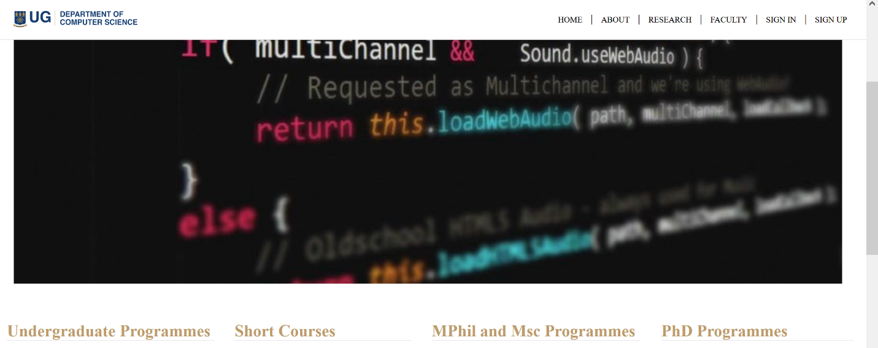

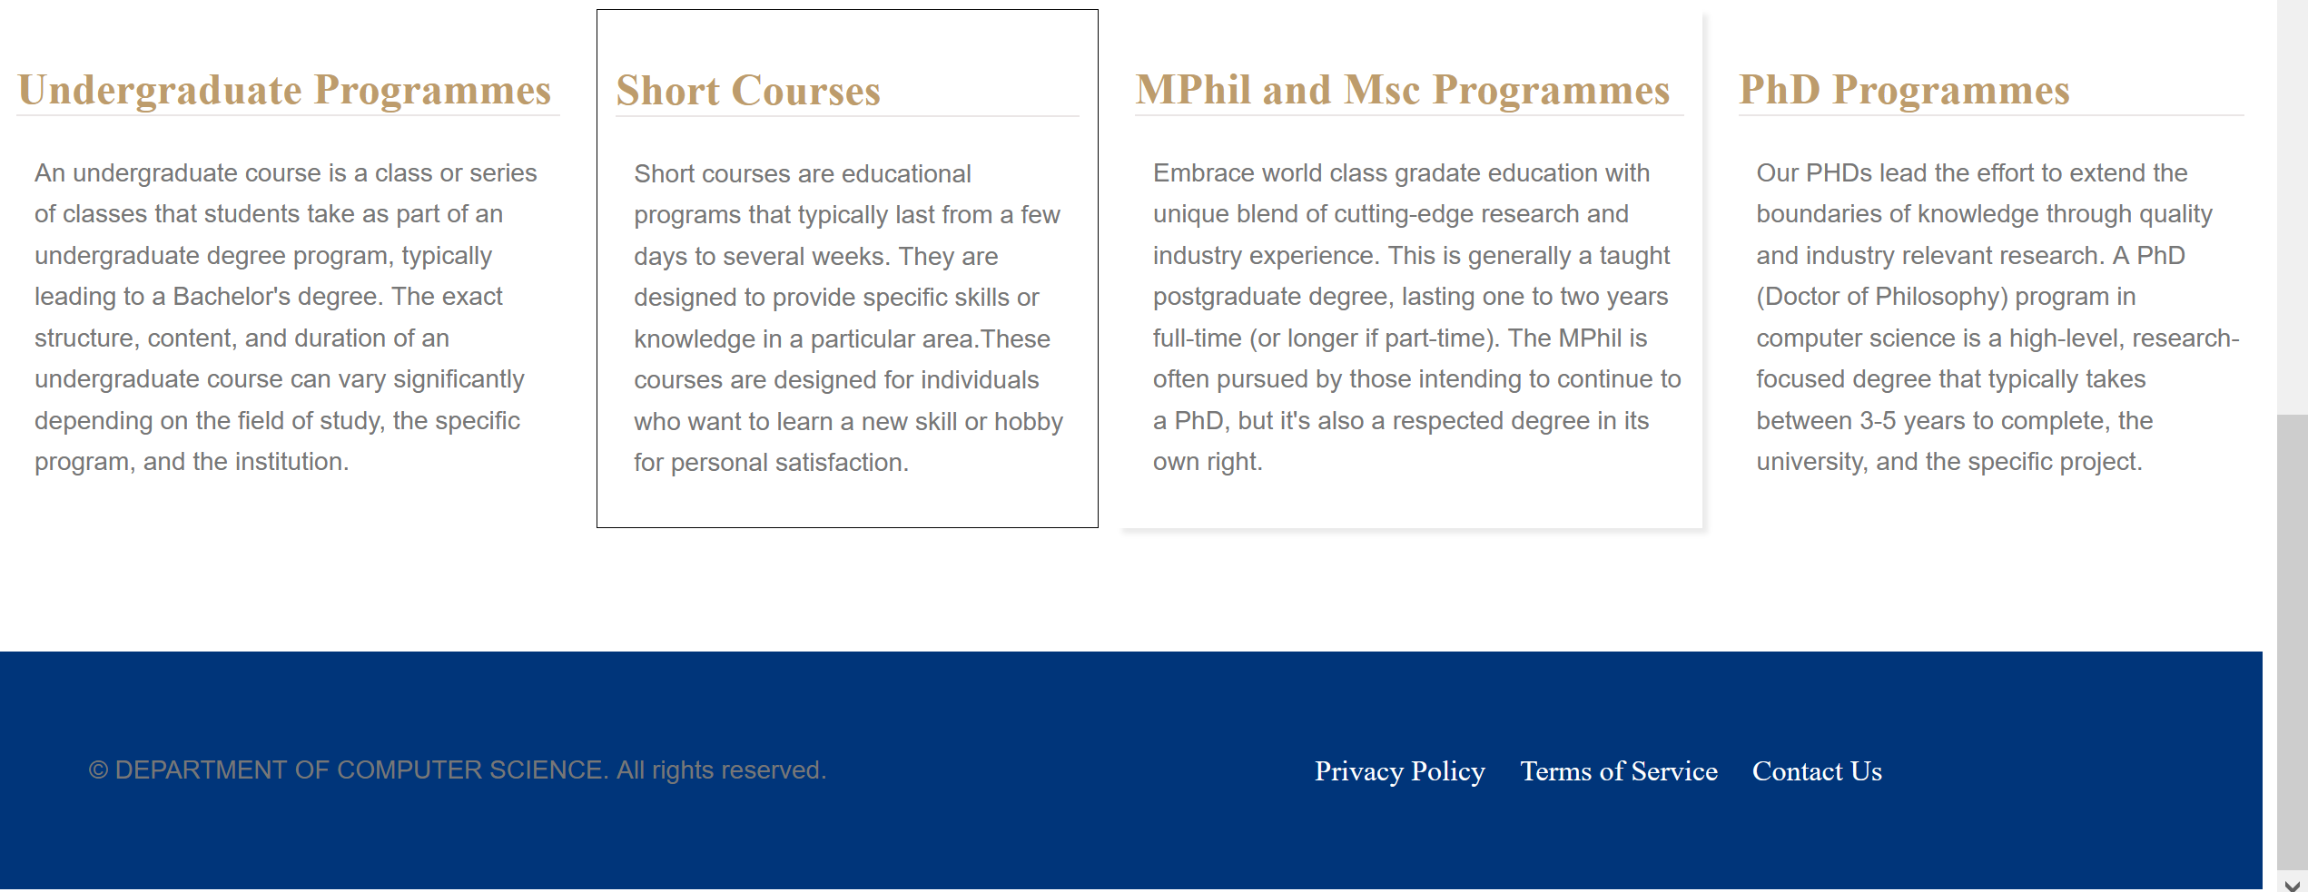

Contact Us

The Contact Us page provides you with various means of getting in touch with our department. If you have any inquiries, suggestions, or feedback, we encourage you to reach out to us through the contact information provided. We value your input and strive to respond to all inquiries in a timely manner.

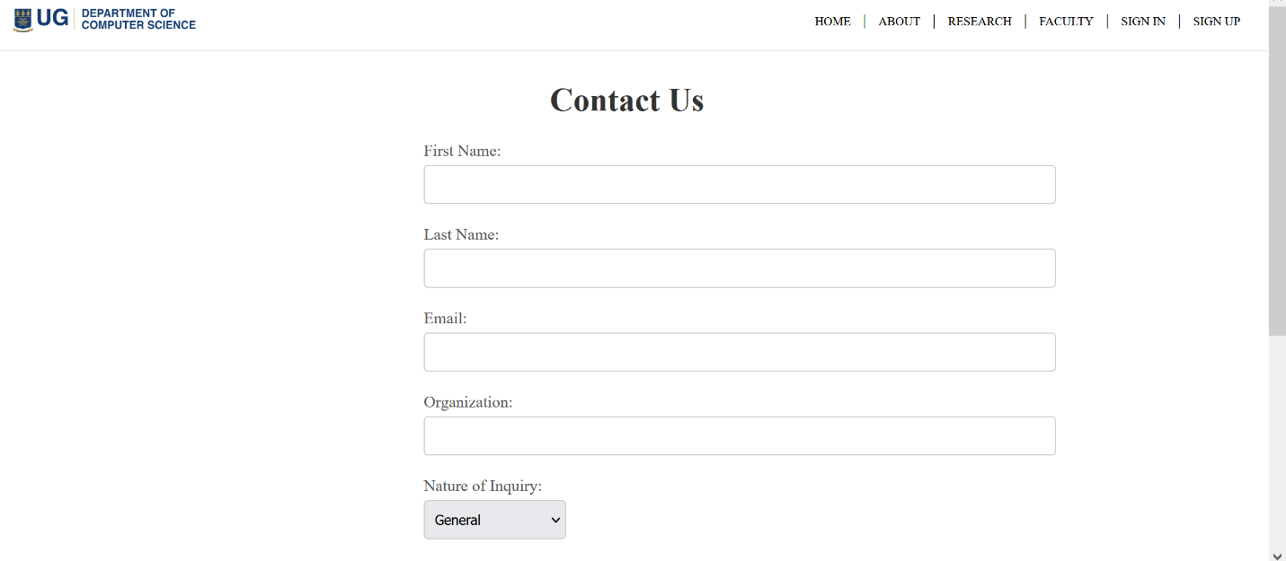

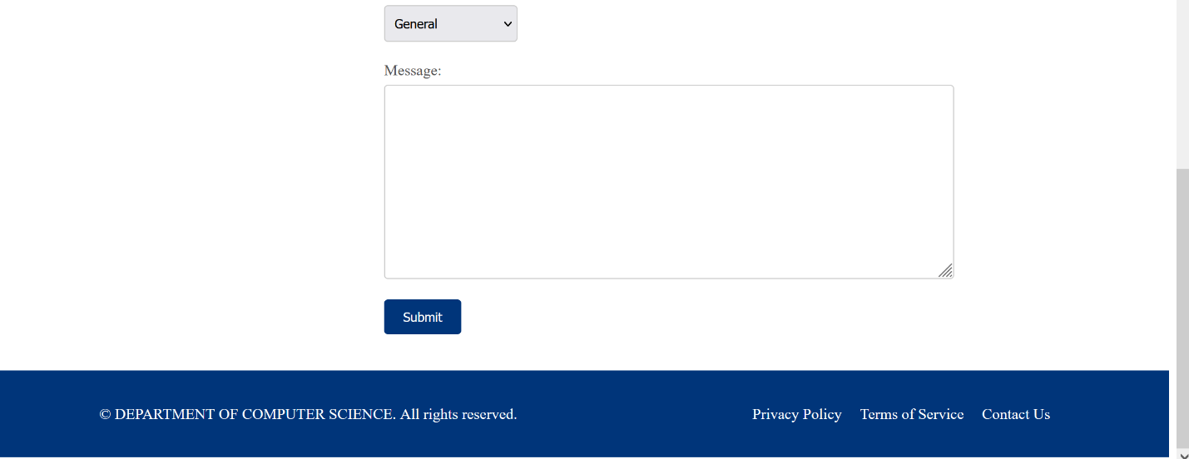

About

The About section offers detailed information about our Computer Department. It includes an overview of our history, goals, achievements, and the faculty members who contribute to the department's success. Additionally, you can learn about any special initiatives, collaborations, or partnerships that we have undertaken.

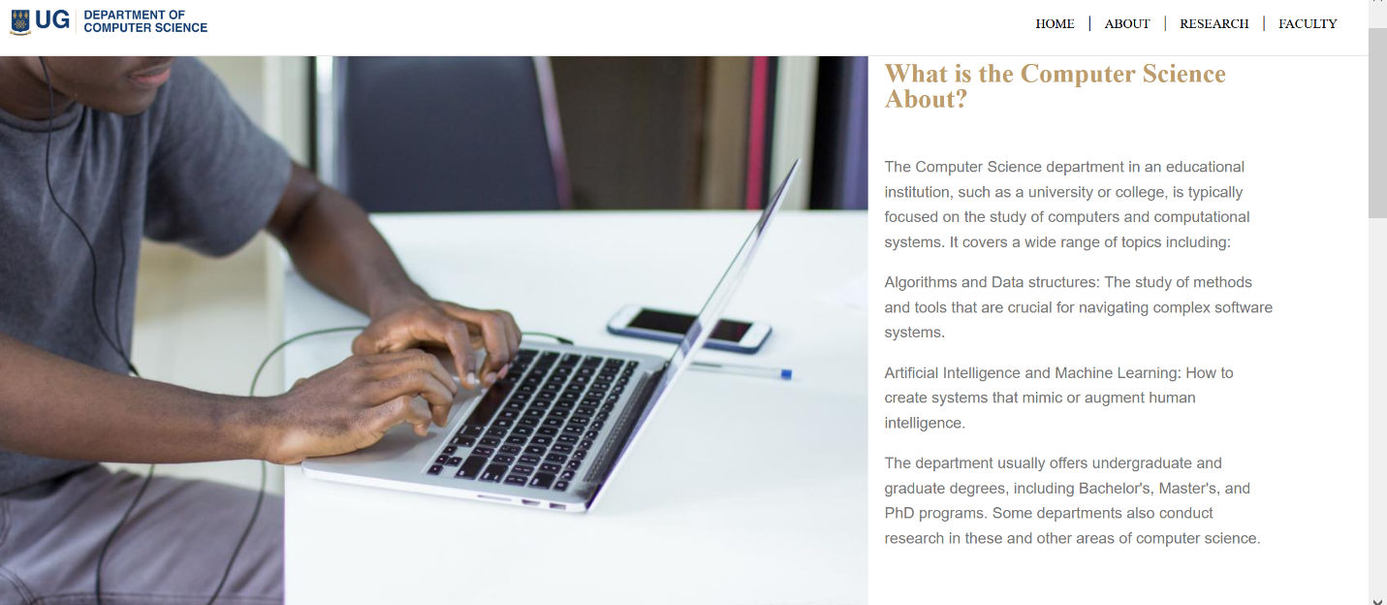

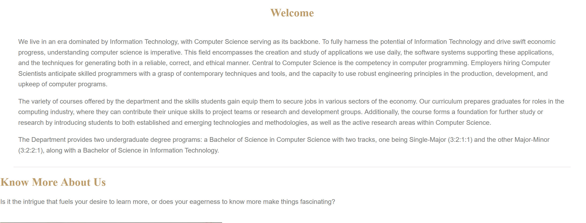

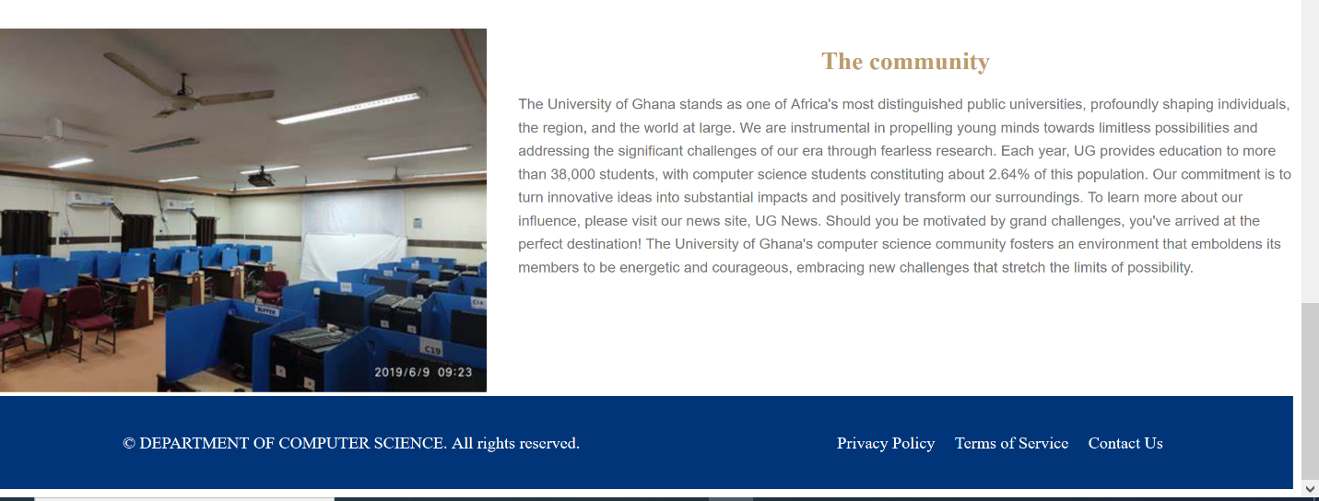

Research

The Research section showcases the cutting-edge research being conducted within our department. Here, you can explore the diverse areas of research, ongoing projects, published papers, and collaborations with other academic or industrial institutions. This section highlights the innovative work carried out by our faculty and students.

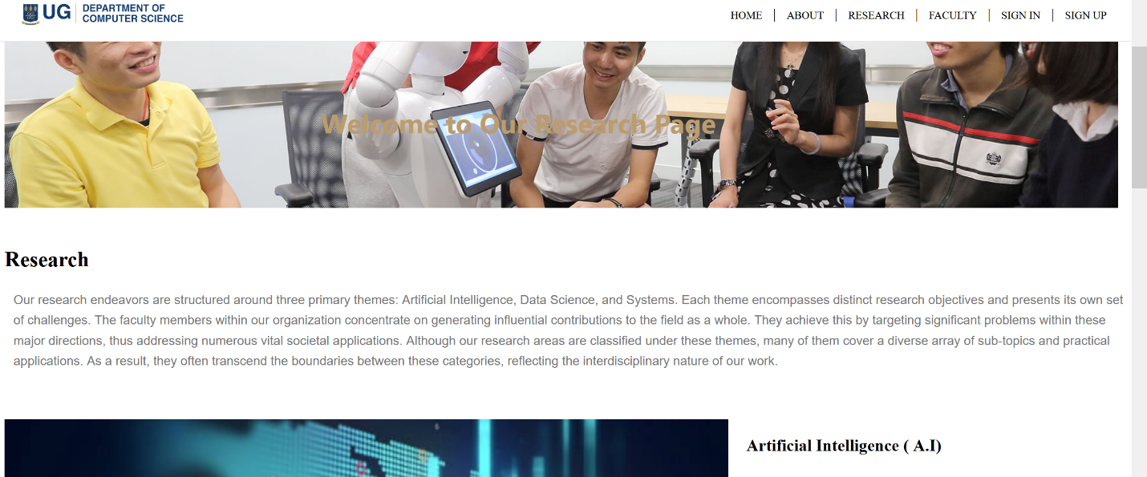

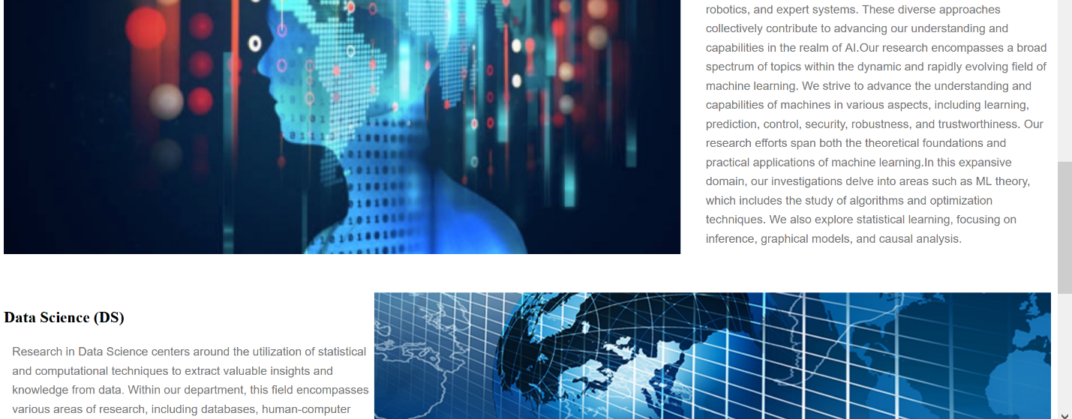

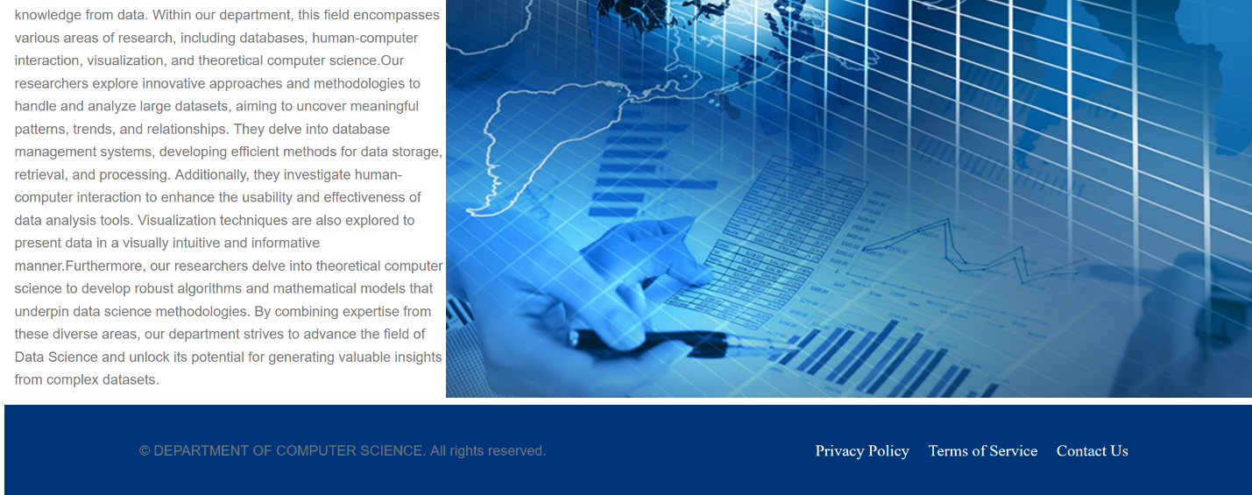

Sign In

The Sign In functionality allows authorized users, such as students and faculty members, to access personalized features on the website. By signing in, users may be able to enroll in courses, access course materials, submit assignments, participate in forums, or perform other relevant actions.

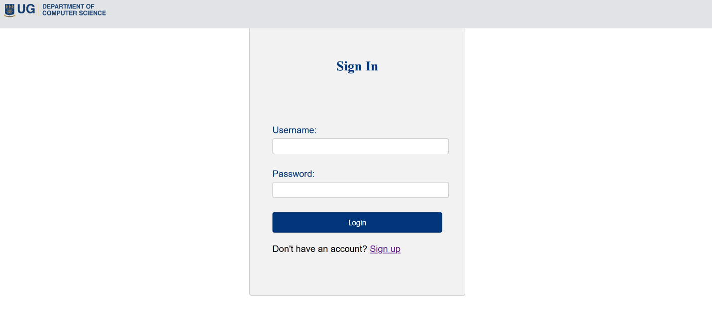

Sign Up

The sign up functionality allows new users, such as student and faculty member to join the computer science department. By signing up, the user is made to enter their information such full name, email address and password to be registered on the site to be able to participate or perform other relevant actions

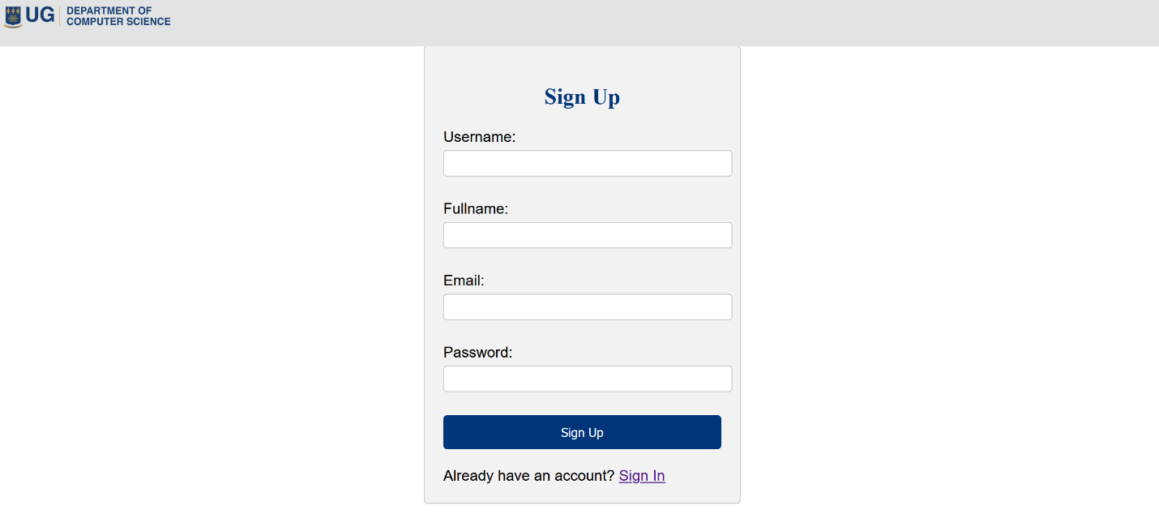

Courses

The Courses section provides comprehensive information about the various computer science courses offered by our department. This includes details on course descriptions, prerequisites, schedules, and faculty members teaching the courses. Students can also find information about the curriculum, degree programs, and any additional resources related to their studies.

Undergraduate Programmes

Our undergraduate courses provide a solid foundation in principles and skills. We offer diversity including programming, mathematics, computer architecture many more. Each program is designed to equip you with the necessary knowledge and skills to excel in the field.

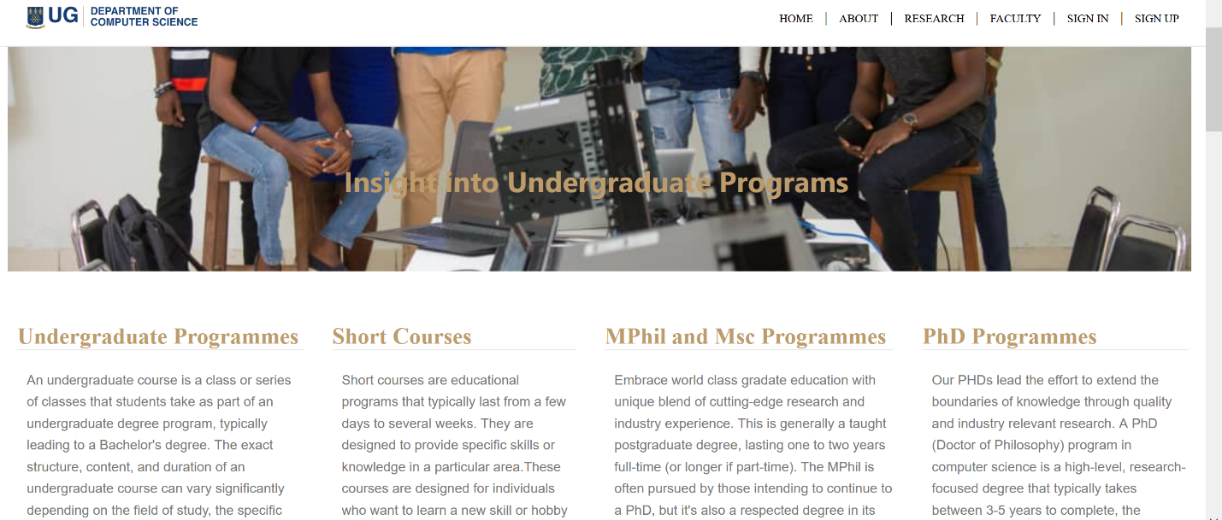

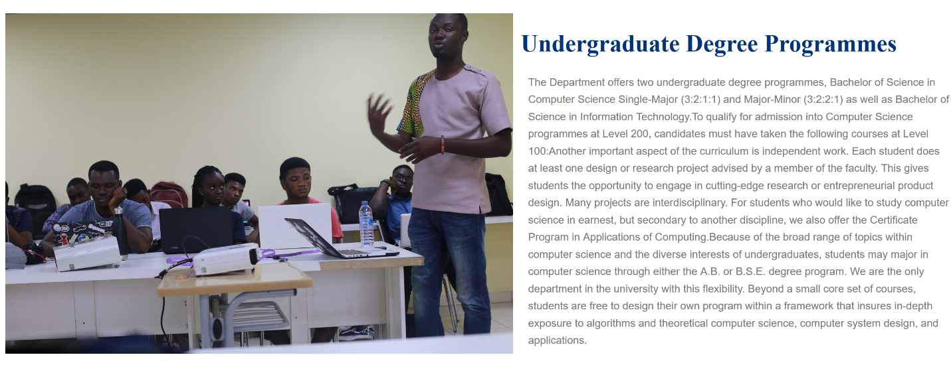

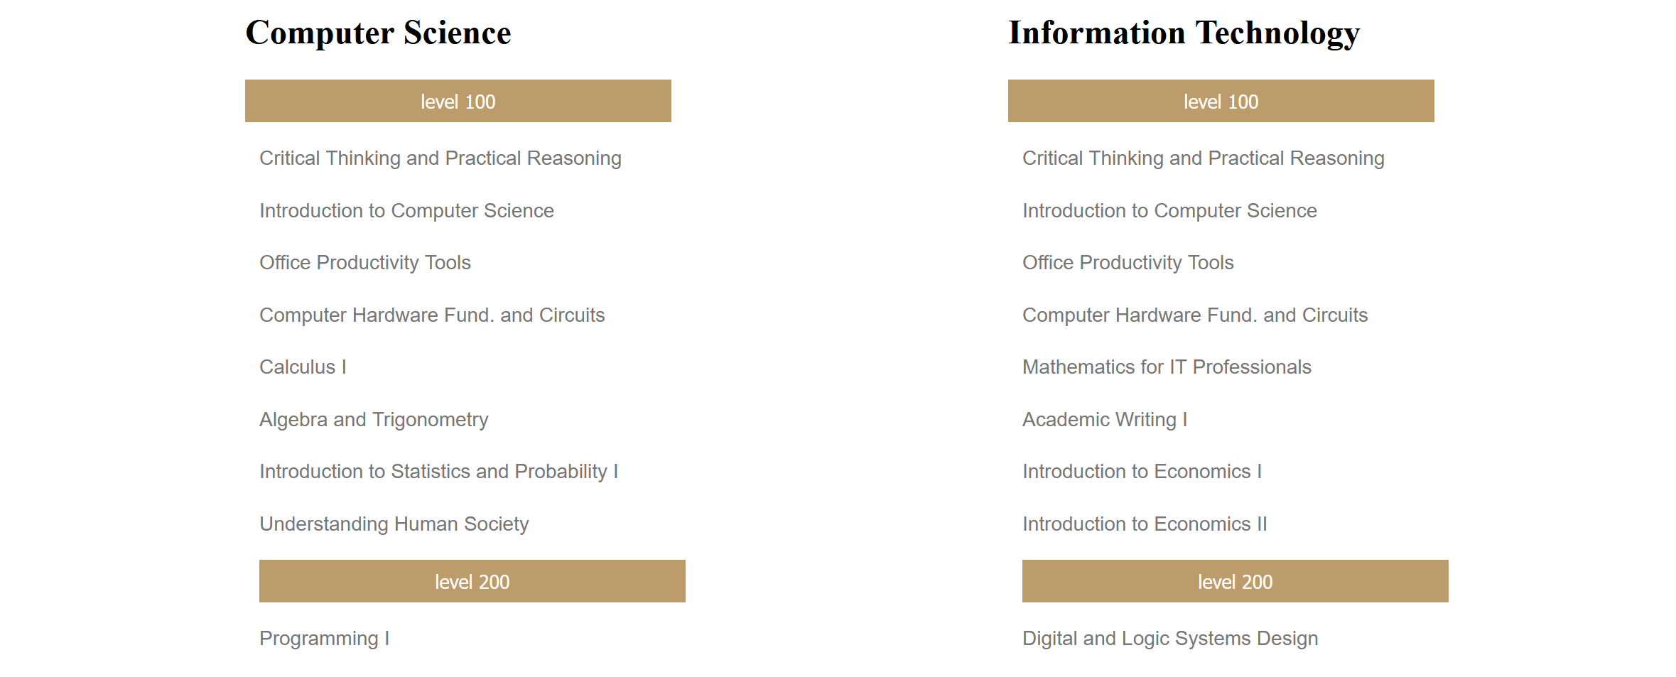

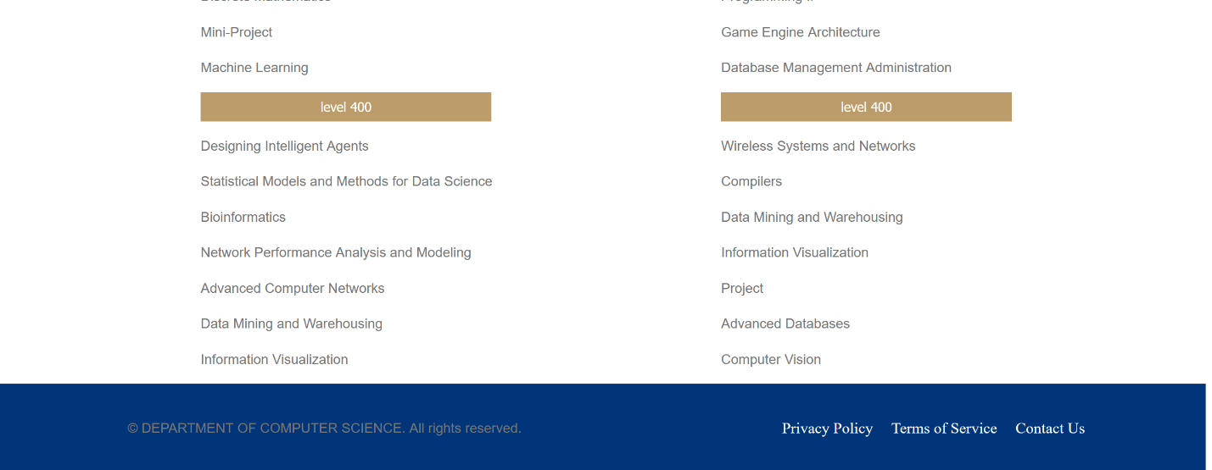

Short Courses

Our short courses are designed to cater to both beginners and experienced professionals looking to expand their knowledge in specific areas of computer science. These courses offer focused and intensive learning opportunities on topics such as machine learning, cybersecurity, web development, data analysis, cloud computing, and others. Whether you want to acquire new skills or enhance your existing ones, our short courses provide a convenient and efficient way to do so.



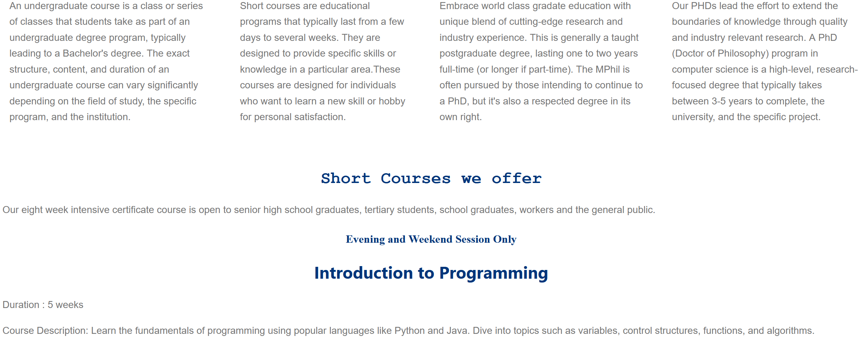

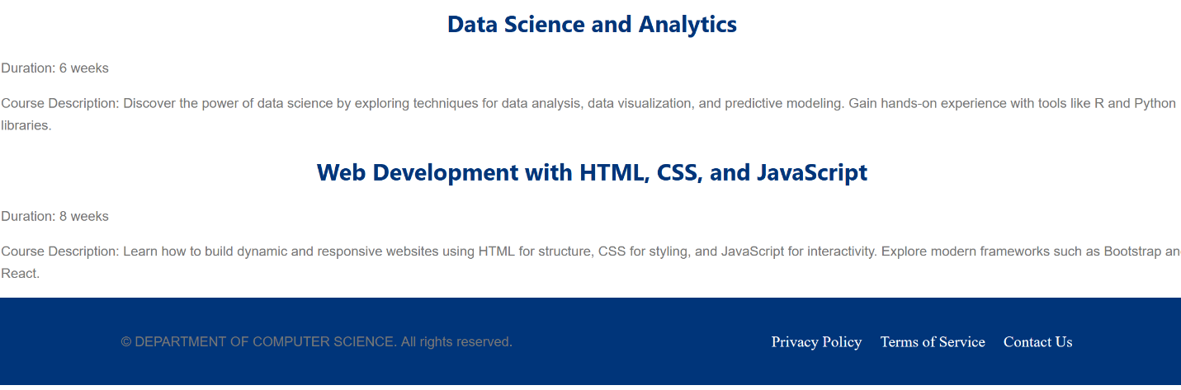

MPhil Programs

For those interested in pursuing advanced studies, we offer MPhil programs in computer science. Our MPhil programs provide in-depth theoretical and practical knowledge, enabling students to conduct independent research and contribute to the field. Each program is carefully crafted to foster critical thinking, problem-solving abilities, and research skills, preparing students for advanced careers in academia or industry.

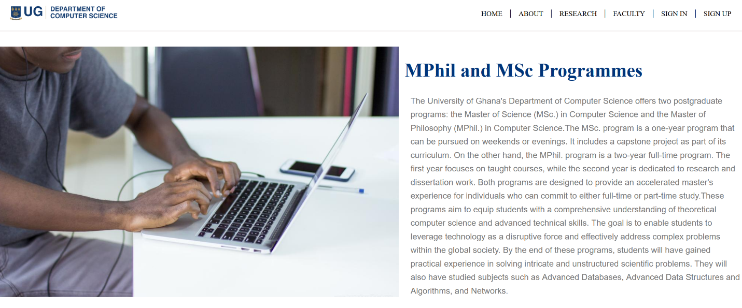

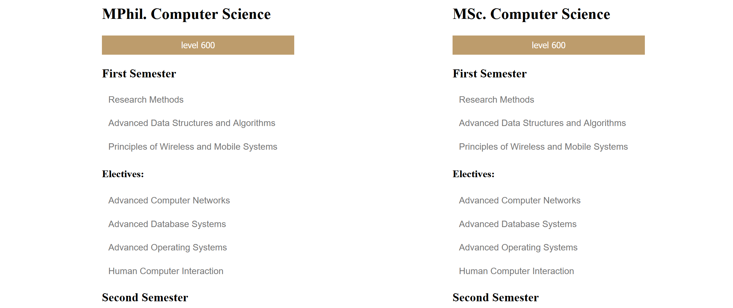

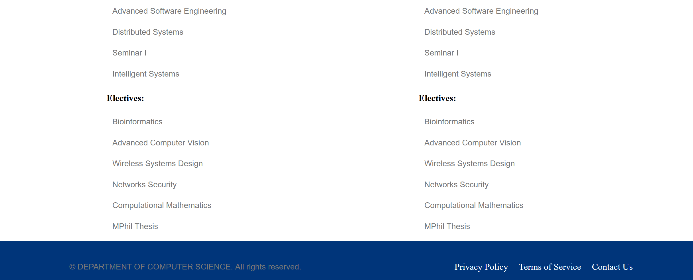

PhD Programs

Our PhD programs are designed for aspiring researchers and scholars seeking to make significant contributions to the field of computer science. Our distinguished faculty and research facilities provide an excellent environment for students to pursue cutting-edge research in various areas, including artificial intelligence, computer vision, data science, human-computer interaction, and more. Our PhD programs empower students to become leading experts and thought leaders in their respective fields.

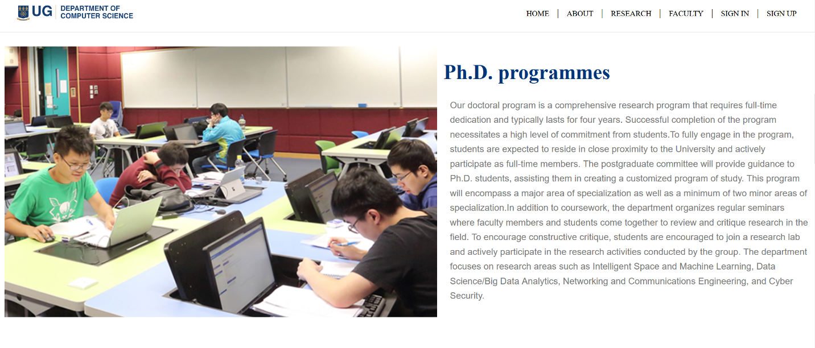



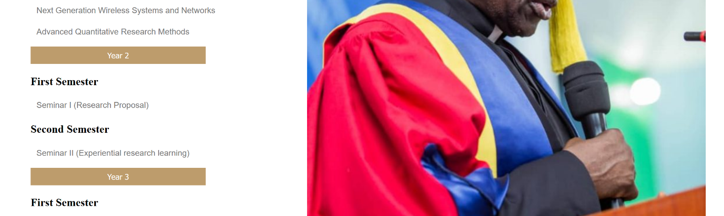

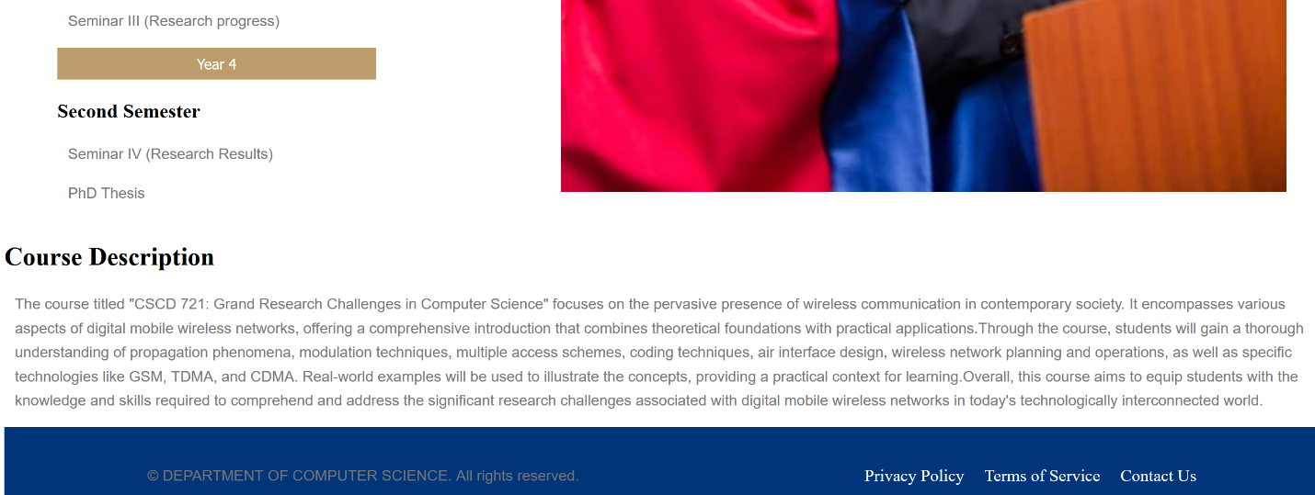

Contributing

We welcome contributions to our website! If you have suggestions for improvement, bug reports, or would like to contribute content, please follow the guidelines outlined in the CONTRIBUTING.md file in our repository.

Acknowledgments

We would like to express our gratitude to all the individuals and organizations that have contributed to the development and maintenance of this website. Their support and dedication have been instrumental in making this resource possible.

Contact Information

- Department of Computer Science

- University of Ghana

- Address: Legon, Accra Ghana

- Phone: + 233 552 713 785

- Email: computerdept@gmail.com

Thank you for visiting our Computer Department website. We hope you find it valuable and informative.